**Online Education Employment Project (Website)**

**Final Report**

VEL Team

Date: 04/OCT/2015

Document Modification History/Revision log

|  |  |  |  |
| --- | --- | --- | --- |
| Version | Date | Author | Description of Change |
| 1.0 | 04/10/2015 | Shawn | Initial version |
| 2.0 | 05/10/2015 | Shawn | Integrate others’ contributions |
|  |  |  |  |
|  |  |  |  |
|  |  |  |  |

Content

Project Description: 1

Delivered Software Increment 2

Completed Product Backlog 2

Sprint Backlog 4

Prototype Details 6

NUnit Tests 14

Mobile Friendly Test (Google) 14

Scrum Management 15

Sprint Review 17

Retrospective 17

Group Evaluation: 18

# Project Introduction

## Product description

The goal of this project is to create an adaptive (mobile friendly) website to help IT students and unemployed people to get useful skills. The home page should draw visitors’ attention so that they would like to register as fixed users. And users can choose the courses they want to take according to some success stories. We use the .NET Framework and the Visual Studio development environment to develop the website.

## Team overview

|  |  |  |  |  |
| --- | --- | --- | --- | --- |
| *No.* | *GitHub username* | *SeeNowDo* | *Official name* | *UPI* |
| *1* | gaoyiqun | Irene | Yiqun Gao | YGAO742 |
| *2* | huajinxie | Kaii | Huajin Xie | HXIE519 |
| *3* | likaihe | Likai | Likai He | LHE838 |
| *4* | lulujing | LuLu | Jing Lu | JLU986 |
| *5* | vasanthnewzealand | V | Vasanth Boraiyan | VBOR051 |
| *6* | yazang | Clay | Chen Yang | CYAN988 |
| *7* | yinqi522 | Miranda | Yu Guo | YGUO425 |
| *8* | YsqEvilmax | Shawn | Shaoqing Yu | SYU702 |
|  |  |  |  |  |

# Requirement Analysis

## Product Backlog

|  |  |  |  |
| --- | --- | --- | --- |
| **No.** | **Completed User Stories** |  | **Relative tasks** |
| 1. | As CEO,  I would like to re-design our website (first page) to make it mobile friendly. | So that we can meet ranking requirement, because Google adopted mobile-friendliness as a ranking signal. | (Home Pages) |
| 2. | As a VISITOR (anonymous user),  I would like to read some success stories of previous students and select the same courses. | So that I can follow the same approach and select suitable courses accordingly. | (Success stories List Pages) |
| 3. | As a VISITOR (anonymous user),  I would like to read the detail of some success story and get to know what courses they’ve learned. | So that I can order the same courses. | (Success stories detail pages) |
| 4. | As CEO,  I would like our team profile and FAQ to be well noticed. | So that we can provide more detail information about our company. | (Team Profile & FAQs Page) |
| 5. | As an ADMIN (course advisor),  I would like to maintain success stories with Add, Update, and Delete. | So I can update and maintain the story pages. | (Admin functions of success story pages included add, edit, delete pages) |
| 6. | As a USER,  I would like to login to my category (Admin or Students) in the system. | So I can maintain or learn on the website. | (Login Pages) |

## Extensional Product Backlog

|  |  |  |  |
| --- | --- | --- | --- |
| **No.** | **Completed User Stories** |  | **Relative tasks** |
| 1. | As a CEO, I want the main page could be brief but interesting. | So that visitors can be attracted. | (Home pages) |
| 2. | As the CEO, I want my customs can share their story page through social networks such as Facebook, Twitter, Google+ and LinkedIn. | So that they can promote our company. | (Success stories list page) |
| 3. | As the CEO, I want to put my team member's LinkedIn link on team profile page. | So that people can gain more confidence about our profession and experience. | (Team profile index page) |
| 4. | As a Visitor, I want an individual page to demonstrate the functionalities of the automation testing tool. | So that I can decide whether to study or not. | (Automation testing toll page) |
| 5. | As a visitor, I want to leave messages on the website. | So that I can get contact with the company. | (Home page) |
| 6. | As a CEO, I want to know how to make my website stand out from google searching results. | So that I can change the keywords with some strategies. | (Research report) |

# Development Plan



## Client Meeting Plan

The available time of Client Meeting, at client’s office are as following.

|  |  |  |
| --- | --- | --- |
| No. | Week Day | Time |
| 1 | Monday | 5:00 pm ~ 6:00 pm |
| 2 | Tuesday | 5:00 pm ~ 6:00 pm |
| 3 | Wednesday | 5:00 pm ~ 6:00 pm |
| 4 | Thursday | 5:00 pm ~ 6:00 pm |
| 5 | Friday | 5:00 pm ~ 6:00 pm |

## Team Meeting Plan

Team internal communication plan defined as below:

|  |  |  |  |  |  |
| --- | --- | --- | --- | --- | --- |
| No. | Meeting | Purpose | Participant | Frequency | Time |
| 1 | Daily Scrum | Check team progress regularly | All team members | Weekly | As following |
| 2 | Sprint Planning | Confirm user stories, break it down into tasks and discuss the design of it | All team members,  Product owner | Bi-weekly | Friday,  9:00 ~ |
| 3 | Retrospective | Discuss what is good or bad in last sprint and make new strategy to improve the process | All team members,  Product owner | Bi-weekly | Friday  11:00 ~ |
| 4 | Design meeting | Discuss the architecture and design of function to make sure team members understand the details | All team members | <TBD>  Base on the result of daily scrum | <TBD> |

Timetable of regularly weekly meeting

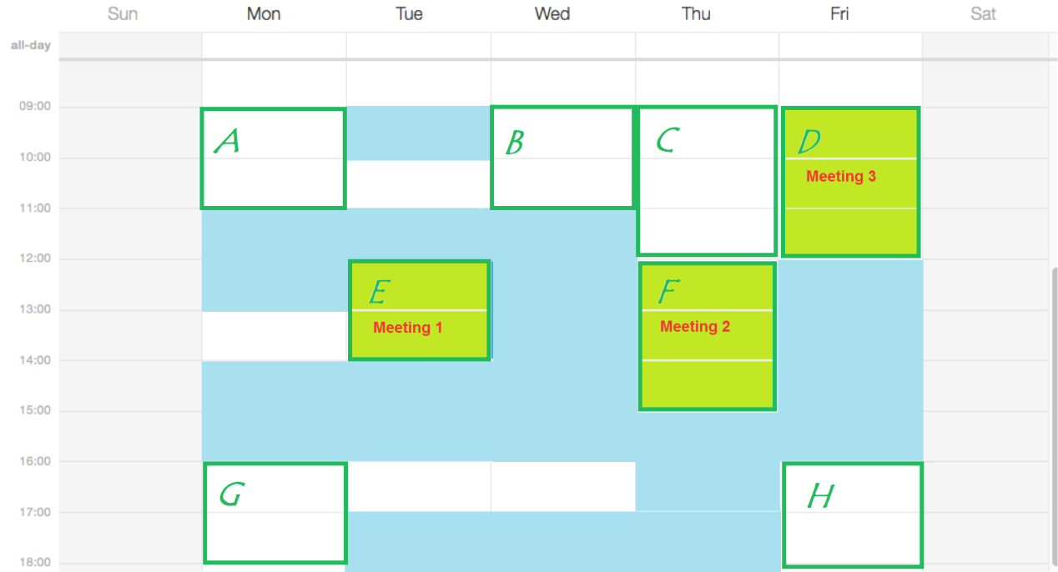

## Project Development Plan

Software development approach is consist of 4 parts: Design Workshop and Sprint 1,2,3. In the design workshop, a mock up model will be delivered, as a demonstration of what can be done, and how system works. And in each following sprint, core functionality will be built, and new features will be incrementally add. Software Testing will be applied within each sprint to ensure functionality correctness, usability and robustness of the system.

**Design Workshop (Duration 1 week)**

A mock up system with minimum functionality and show case of adaption to different size of device will be developed. Including web site main page, course list and course details.

Each page should be fully customized to adapt desktop/laptop, tablet and mobile phone. Program should be able to detect and apply customized layout framework for each screen size.

Deliverable consist of a demo system with mock up data.

**Sprint 1**

Core function of the system will be developed in this phase, including main page, course list and course detail, dynamic menu, course category. Each page will be applied by size adaption framework, tuned and tested on each screen size device. Server interaction will be concurrently developed.

Deliverable consist of minimum fully functional online course web site, with well tuned adaption to each screen size device from desktop/laptop, tablet to mobile phone.

**Sprint 2**

Implement visitor customized content, categorized success stories and dynamic recommended courses. Focus on functionality on recognition of visitor’s personal background and behaviour, generate customized content for each type of visitor, and display successfully stories and corresponding courses which leads to high possibility of commit deals.

Deliverable consist of visitor recognition functionality, dynamic content based on visitor’s category, successful stories and list of corresponding courses. Integrated with sprint 1.

**Sprint 3**

On-line help desk, shopping cart, and other potential customer requirements. These are add-on features to the system. According to the customer, these functionalities need further discussion. As for now, development plan for this part of the project is not clarified. Refinement of product backlog will be done along while project on-going.

Deliverable to be decided.

**Software Testing**

Test scenarios will be designed and test cases will be executed within each sprint. Defect management tool will be used on demands. Defects will be labelled with 3 levels of severity:

• Critical – system clash, module level failure, infrastructure failure, etc.

• Major – functional misbehaviour, missing functionality, etc.

• Minor – layout issue, user friendly issue, issues with work around, etc.

Testing scope include unit testing, integration testing and system testing. There will be organized integration testing and system testing within each sprint, before customer acceptance tests.

Deliverable consist of test reports.

**Software Release**

System will be bundled as deployable, together with design documents, test reports, installation guide and user guide.

## Risk Management Plan

Risk Management is a process that ensures any issues are identified early and addressed before they jeopardize project objectives. The process will follow all stages from creating a risk management strategy through managing risk tracking to executing a risk management plan.

The Risk Tracking will be carried out after daily scrum. It is used to manage Risks that have a significant effect on project progress and outcomes. In addition to managing Risks, the process provides a method for documenting the rationale behind risk mitigation decisions made during one stage of the project that may affect a later stage.

Supporting this process is the Risk Tracking table that provides a centralized location for tracking Risks. Documentation for this can be found in the GitHub, located /PCB/02 Plans & Actuals/2.3_Risk & Issue. The Risk Tracking Process and tool allow the user to identify and assess each risk, as well as track the progress towards mitigation.

## Change Management Plan

Changing requirement is welcome, even late. [Principles behind the Agile Manifesto]

* The Product Owner is responsible for ensuring the integrity of work products backlog within a project and introduction of changing requirement during sprint planning.
* Scrum master and team will implement change control processes during daily scrum in case of the change requirement can affect the scope of current sprint.

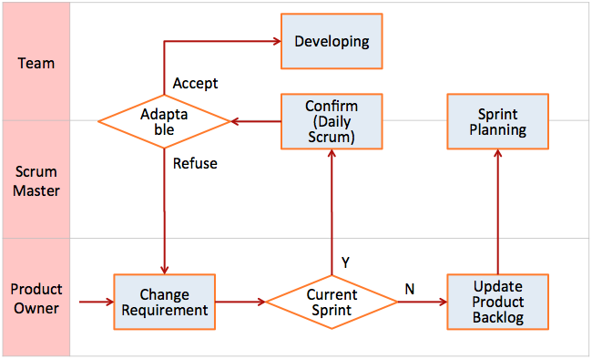

# Project Configuration



## Scrum Management Tool

**SeeNowDo** will be used to monitor project approach, user stories, sprint plans, and development progress. Meanwhile, burn-down chart is provided to indicate whether the project is meeting its target schedule and budget.

* URL to login SeeNowDo:

<https://www.seenowdo.com/pages/login/index.xhtml>

* Project Name: **OEE(Android)**
* Main board

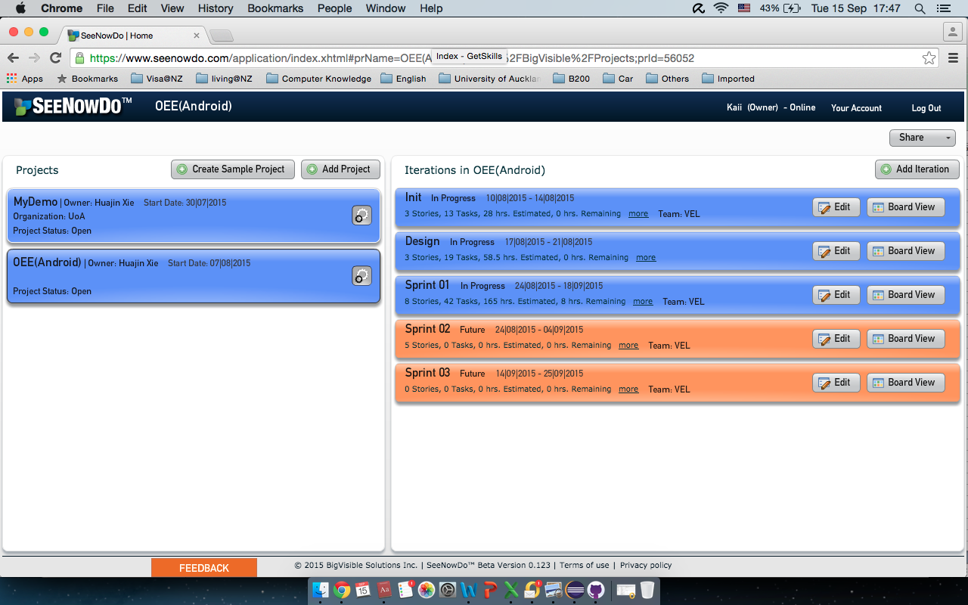

## Source Management Tool

GitHub will be used to manager documents and source file.

* URL to login GitHub:

<https://github.com/>

* Project Name: **761_VEL**
* Image of GitHub

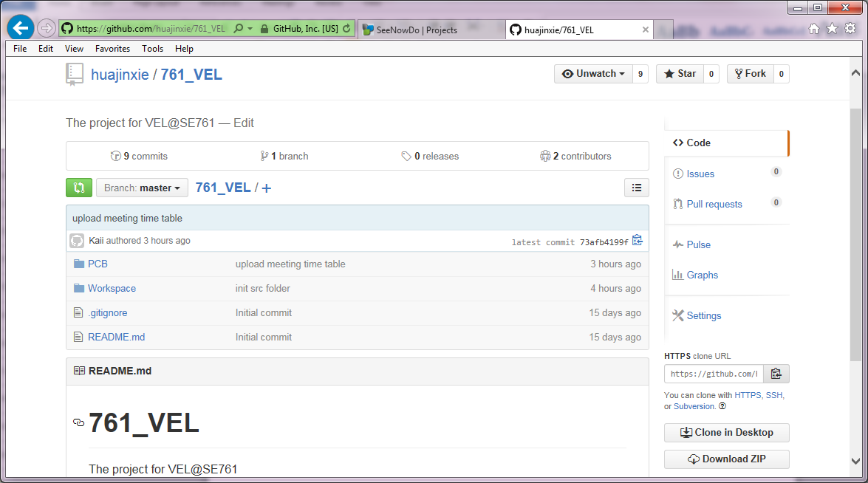

# Sprint 01

## Delivered Software Increment

Our team have finished 6 user stories in the product backlog in the past Sprint. The prototype is a website include Login function, Admin function, homepages, Success story list pages and detail pages. This website use a 3 tier architecture. Communication and data exchange between the 3 layers can be easily achieved with Model-View-Controller (MVC 5) patterns. The presentation layer, business logic layer and database layer, can be easily developed and maintained separately by using MVC 5. We’ve also redesigned Database, to ensure that no conflict in the DB integration.

Currently completed pages and functions in the prototype can be tracked through two flows – Admin flow and Visitor flow:

From the Admin Flow:

Homepages 🡪 Login page (Admin) 🡪 Success Story List Admin Pages 🡪 Success Story Detail Admin pages 🡪 Success Story Detail Admin Pages (Add/Edit/Delete) 🡪 Success Story List Admin Pages

Form the Visitor Flow:

1. Homepages 🡪 Success Story List Pages 🡪 Success Story Detail Pages
2. Homepages 🡪 Team Profile Pages 🡪 FAQs Pages

## Sprint Backlog

|  |  |  |  |  |  |  |
| --- | --- | --- | --- | --- | --- | --- |
| Story  ID | User Story | Task  ID | Task | Owner &  Participant | UPI | Hours |
| 1 | Refine Home Page | 11 | Change carousel to success story & Height | ClayY | CYAN988 | 5.0 |
|  |  | 12 | Website statistics | Irene | YGAO742 | 3.0 |
|  |  | 13 | UT for carousel | Shawn | SYU702 | 2.5 |
|  |  | 14 | UT for website statistics | LikaiH | LHE838 | 1.5 |
| 2 | Refine Success Story List | 21 | Share icons for social media | Shawn | SYU702 | 6.0 |
|  |  | 22 | Refine success story list page | Lulu | JLU986 | 3.0 |
|  |  | 23 | Refine detail page | Lulu |  | 4.0 |
|  |  | 24 | Unit Test (Story List) | Irene | YGAO742 | 1.0 |
| 3 | Team Profile Admin Function | 45 | Detail Success Story Page | ClayY | CYAN988 | 4.0 |
|  |  | 46 | Test Case (Story Detail) | Miranda | YGUO425 | 3.0 |
|  |  | 47 | Unit Test (Story Detail) | Miranda | YGUO425 | 2.0 |
| 4 | Test Automation Page | 48 | Team profile page | ClayY | CYAN988 | 2.0 |
|  |  | 49 | FAQ page | LikaiH | LHE838 | 2.0 |
| 5 | Contact Function | 51 | Admin (List page) | Kaii | HXIE519 | 9.0 |
|  |  | 52 | Admin (Edit page) | Kaii | HXIE519 | 8.0 |
|  |  | 53 | Admin (Add page) | V | VBOR051 | 7.0 |
|  |  | 53 | Admin (Add page) | Kaii | HXIE519 | 1.0 |
|  |  | 54 | Test Case & NUnit (Add) | Miranda | YGUO425 | 4.0 |
|  |  | 55 | Test Case & NUnit (Edit) | Miranda | YGUO425 | 4.0 |
|  |  | 56 | Test Case & NUnit (List) | Lulu | JLU986 | 4.0 |
|  |  | 57 | Unit Test (Story Detail) | Lulu | JLU986 | 3.0 |
|  |  | 58 | Admin (Delete page) | Kaii | HXIE519 | 3.0 |
| 6 | Google Search Keyword | 61 | Login Page | Miranda | YGUO425 | 6.0 |
|  |  | 62 | Test Case & Nunit (Login) | Irene | YGAO742 | 4.0 |
|  |  | 63 | Unit Test (Login) | Irene | YGAO742 | 1.0 |
| X1 | Scrum Activities | 01 | Client Meeting(25/08/2015) | ALL members |  | 4.0 |
|  |  | 02 | Scrum board init | Kaii | HXIE519 | 1.0 |
|  |  | 03 | Draft tasks list | Kaii | HXIE519 | 1.0 |
|  |  | 91 | Daily Scrum (28/08/2015) | ALL members |  | 1.0 |
|  |  | 92 | Daily Scrum (02/09/2015) | ALL members |  | 1.0 |
|  |  | 93 | Daily Scrum (05/09/2015) | ALL members |  | 1.0 |
|  |  | 94 | Daily Scrum (08/09/2015) | ALL members |  | 1.0 |
|  |  | 95 | Daily Scrum (11/09/2015) | ALL members |  | 1.0 |
|  |  | 96 | Retrospective Meeting | ALL members |  | 4.0 |
|  |  | 97 | Client review Meeting(14/09/2015) | ALL members |  | 6.0 |
|  |  | 98 | Client review Meeting(14/09/2015) | ALL members |  | 2.0 |

## Development Details

1. User Story 1: Refined home page

URL: <http://getskills.azurewebsites.net/>

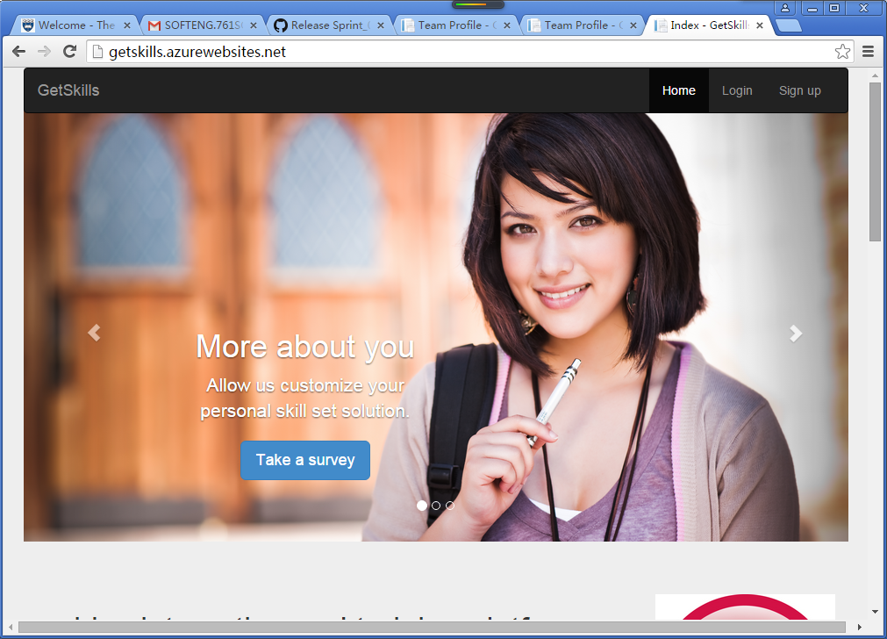

1. User Story 2: As a VISITOR (anonymous user), I would like to read some success stories of previous students.

** At the bottom of the Home Page (<http://getskills.azurewebsites.net/>), there is a link – “Success Stories” located in “Site Map” zone.

URL: <http://getskills.azurewebsites.net/SuccessStory/List>

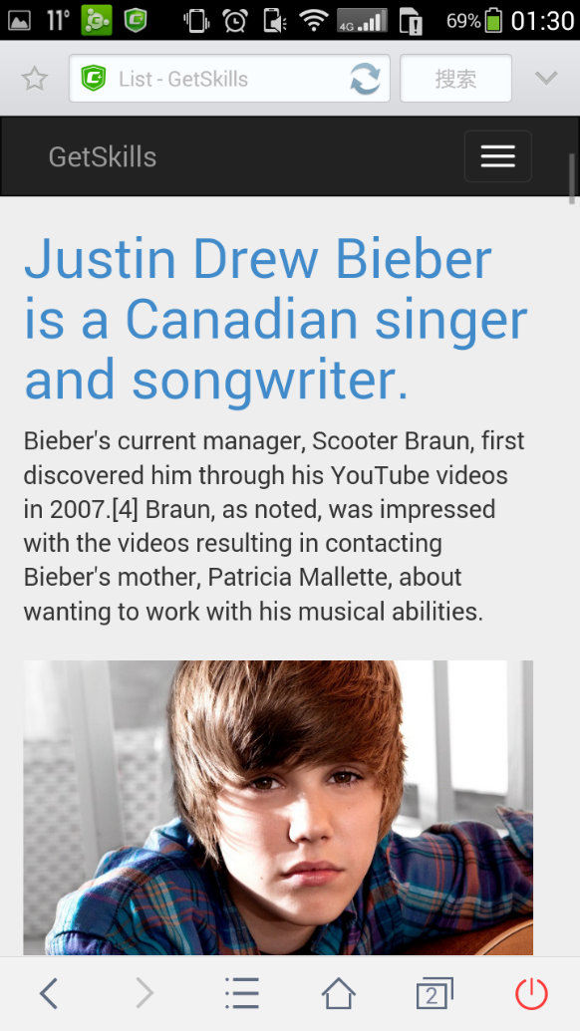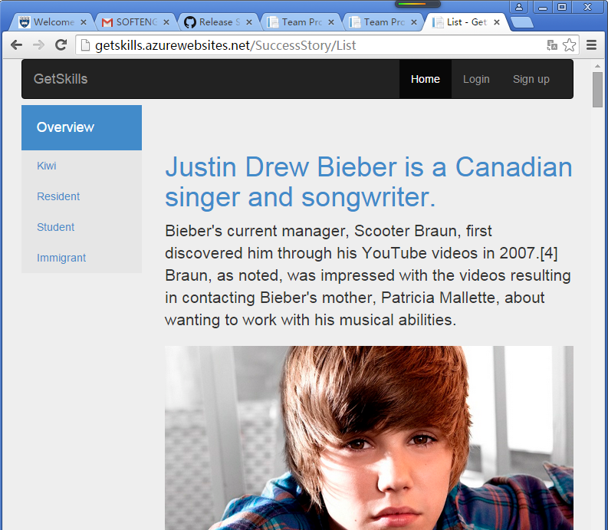

1. User Story 3: As a VISITOR (anonymous user), I would like to read the details of some success stories.

** Click the title of each success story in Success Stories List Page (<http://getskills.azurewebsites.net/SuccessStory/List>), the pages will navigate to the relative Success Story Detail Pages. Visitors can jump back to the Success Stories List Pages by clicking ‘Back to list’ link at bottom.

URL: For example: <http://getskills.azurewebsites.net/SuccessStory/Detail/2>, or <http://getskills.azurewebsites.net/SuccessStory/Detail/1>

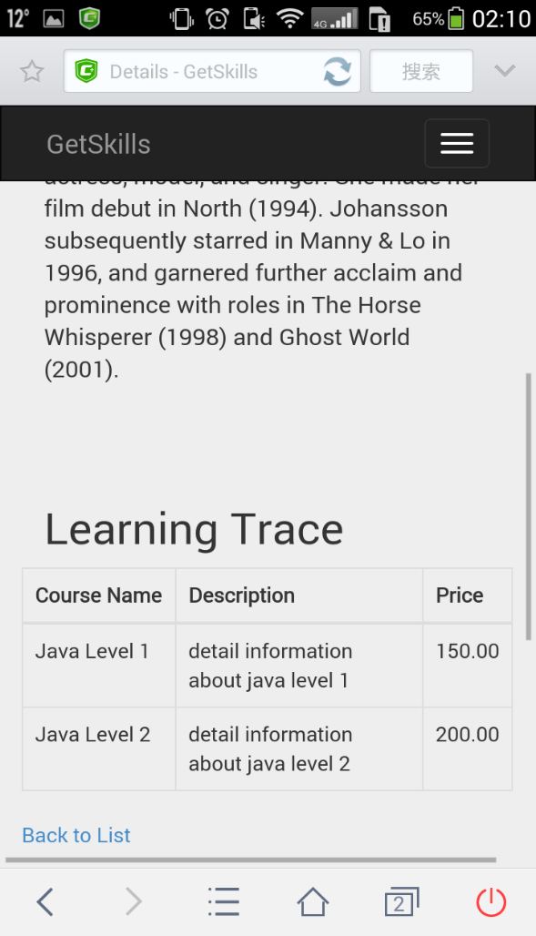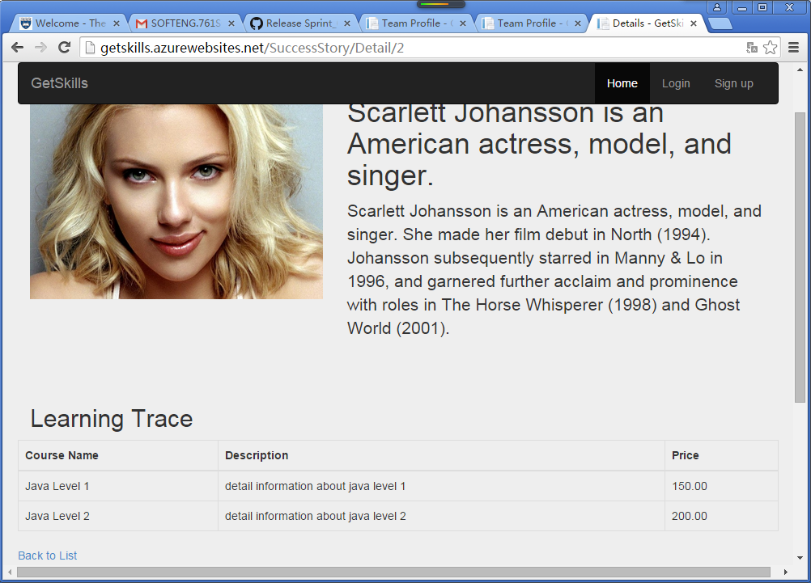

1. User Story 4: As CEO, I would like our team profile and FAQ to be well noticed.

** At the bottom of the Home Page (<http://getskills.azurewebsites.net/>), the ‘Team Profile’ link will lead visitors to the Team Profile Pages

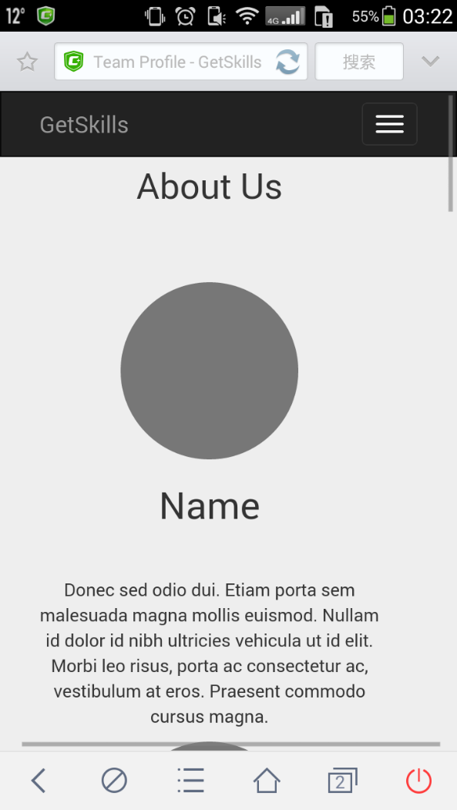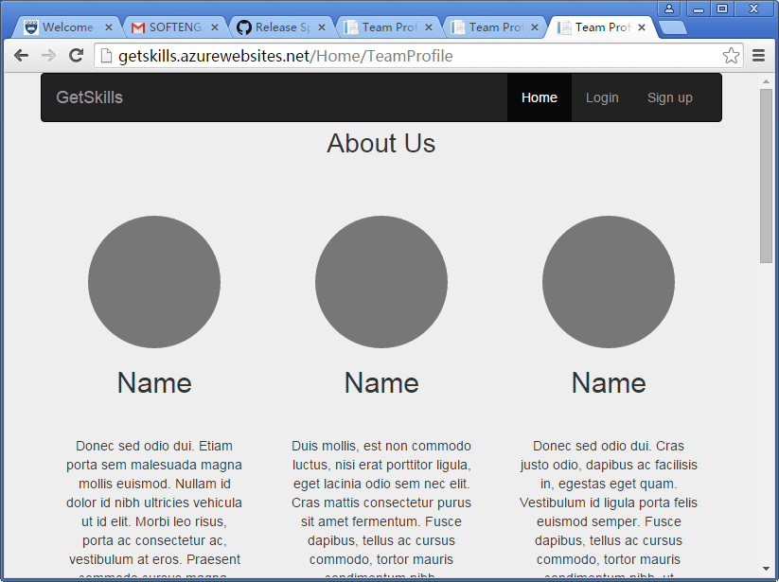URL: <http://getskills.azurewebsites.net/Home/TeamProfile>

** At the bottom of the Home Page (<http://getskills.azurewebsites.net/>), the ‘Team Profile’ link will lead visitors to the Team Profile Pages

URL: <http://getskills.azurewebsites.net/Home/FAQ>

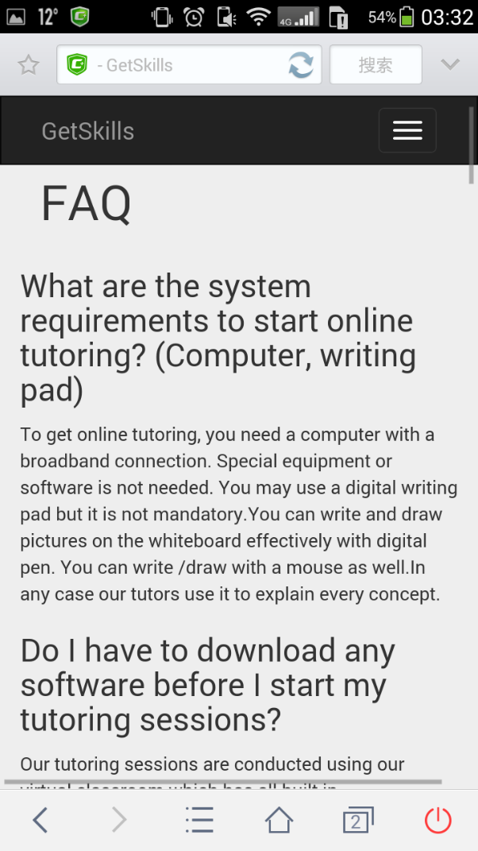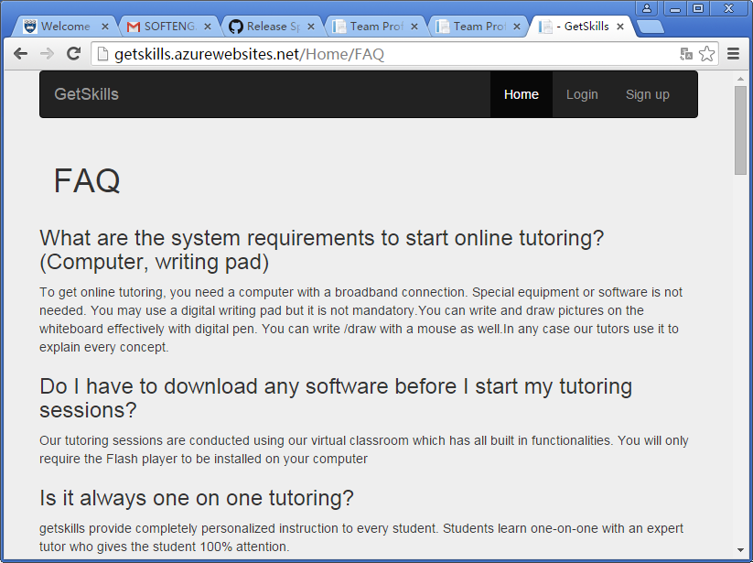

1. User Story 5: As an ADMIN (course advisor), I would like to maintain success stories with Add, Update, and Delete.

** For ADMIN functions, Product Owner informed us that they won’t maintain the stories by using mobile phones. So that we only developed the PC pages.

** Based on security considerations, we decided not to show the ‘Admin Login’ link on public website pages. Administrators can login to ADMIN pages through the link – <http://getskills.azurewebsites.net/Account/AdminLogin>

(UserName: aaaa Password: 123456)

1. Admin URL: <http://getskills.azurewebsites.net/SuccessStory?sortOrder=ID_asc>

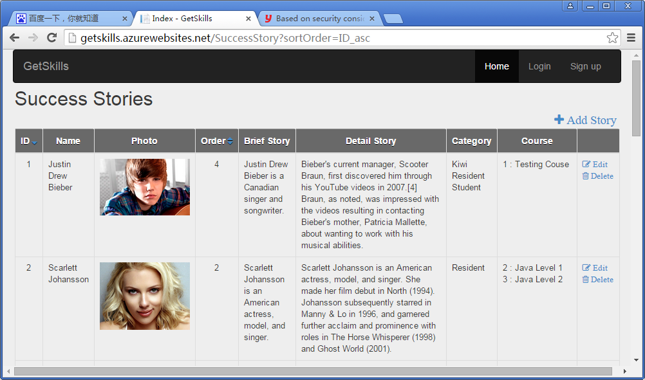

1. By click the “+ Add Story” on Admin pages, administrators can create new success stories.

URL: <http://getskills.azurewebsites.net/SuccessStory/Create>

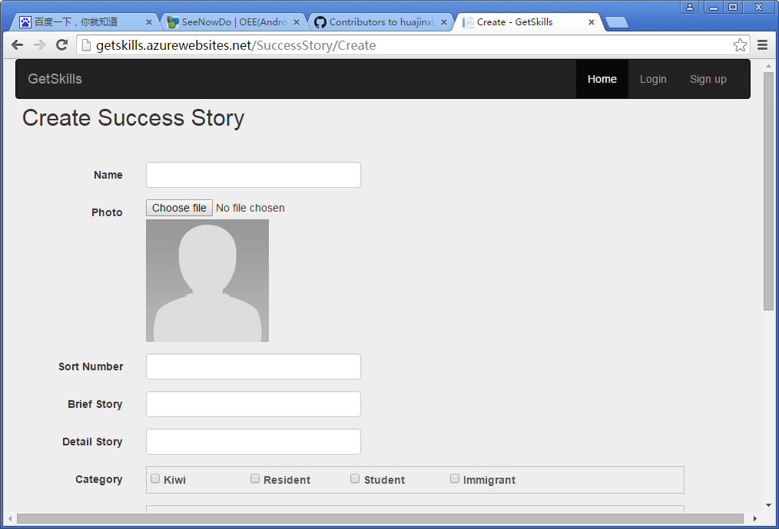

1. By click the “Edit” button after each success stories on Admin pages, administrators can edit exist success stories.

URL: <http://getskills.azurewebsites.net/SuccessStory/Edit/1>

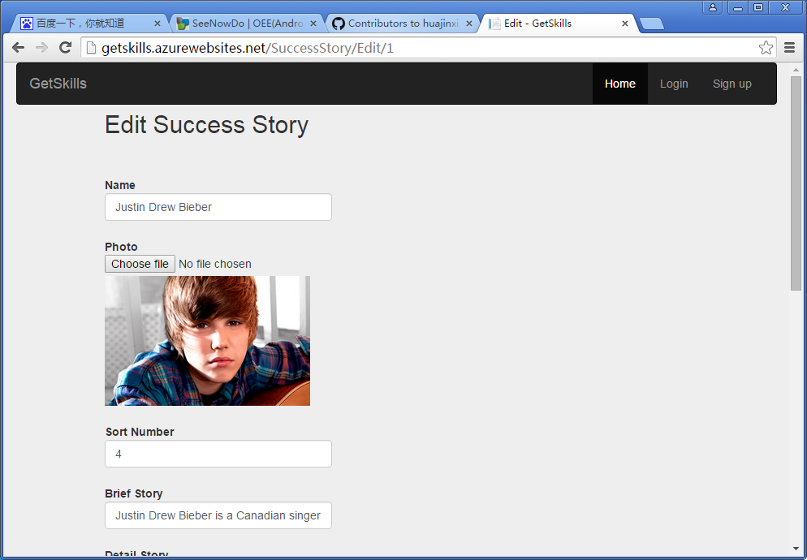

1. By click the “Delete” button after each success stories on Admin pages, administrators can delete exist success stories.

URL: <http://getskills.azurewebsites.net/SuccessStory/Delete/4>

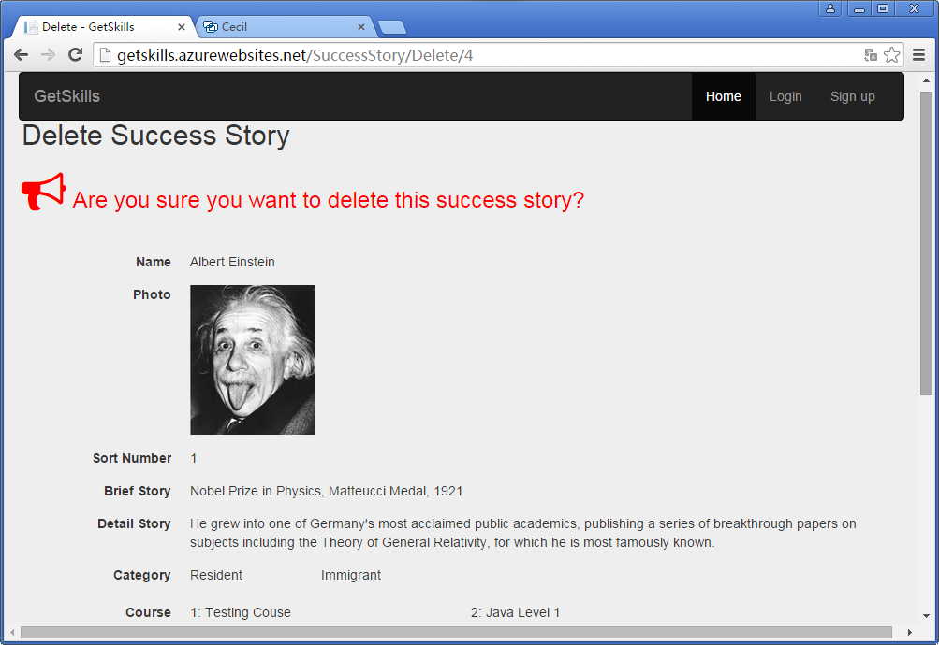

1. User Story 6: As a USER, I would like to login to my category (Admin or Students) in the system.

** No matter which pages visitors are surfing, they can always login/Register in the website by click the related links on heater (Navbar). They can also choose to login by using Google Accounts or Facebook Accounts.

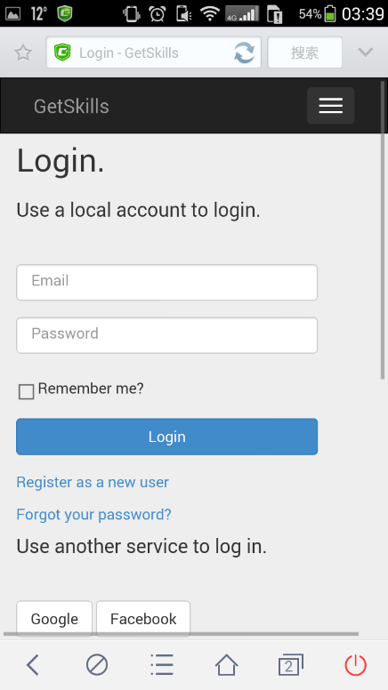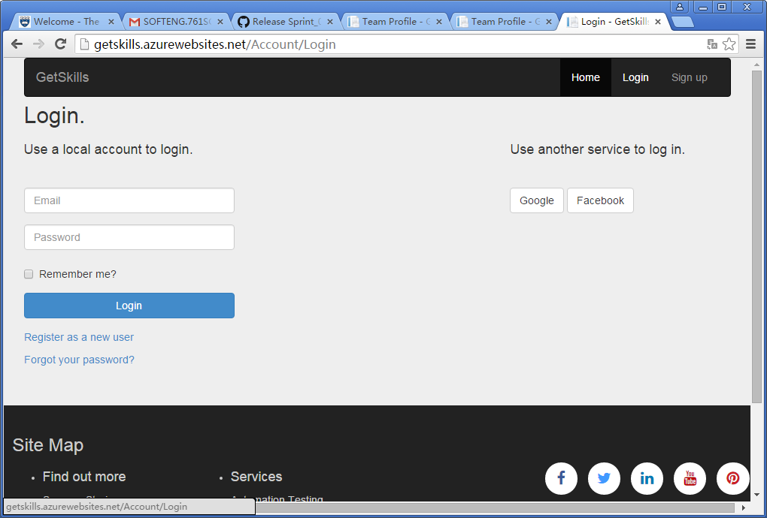URL: <http://getskills.azurewebsites.net/Account/Login>

.

## Test results

### NUnit Tests

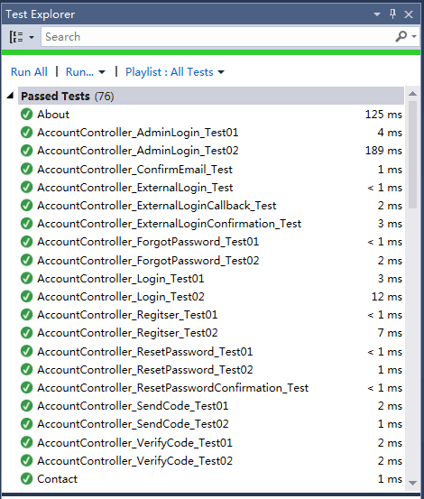We mainly use Nunit, which is an open source unit testing framework for Microsoft .Net, in completing the test cases and Unit tests processes.

In our project, Unit testing for Web Page are implemented. And NUnit testing are implemented for all Controller Classes and methods. Our tests also including sync unit tests.

The methods in controllers have been tested as more as possible. The source codes have passed all of the 76 test cases.

### Mobile Friendly Test (Google)

• Test result of old system: Un-friendly • Test result of new system: Mobile friendly

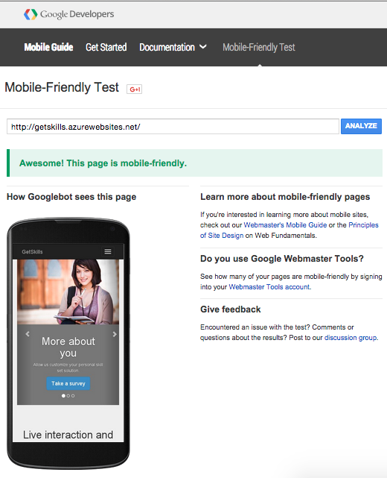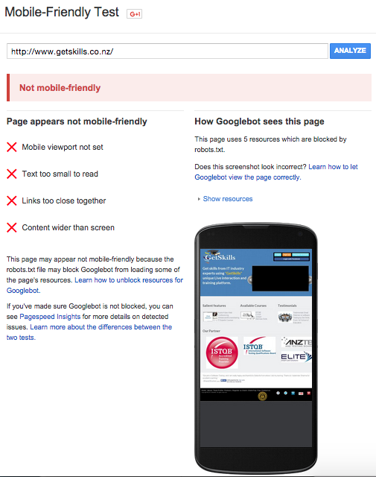

## Sprint Management

* Scrum Board (Sprint 01)

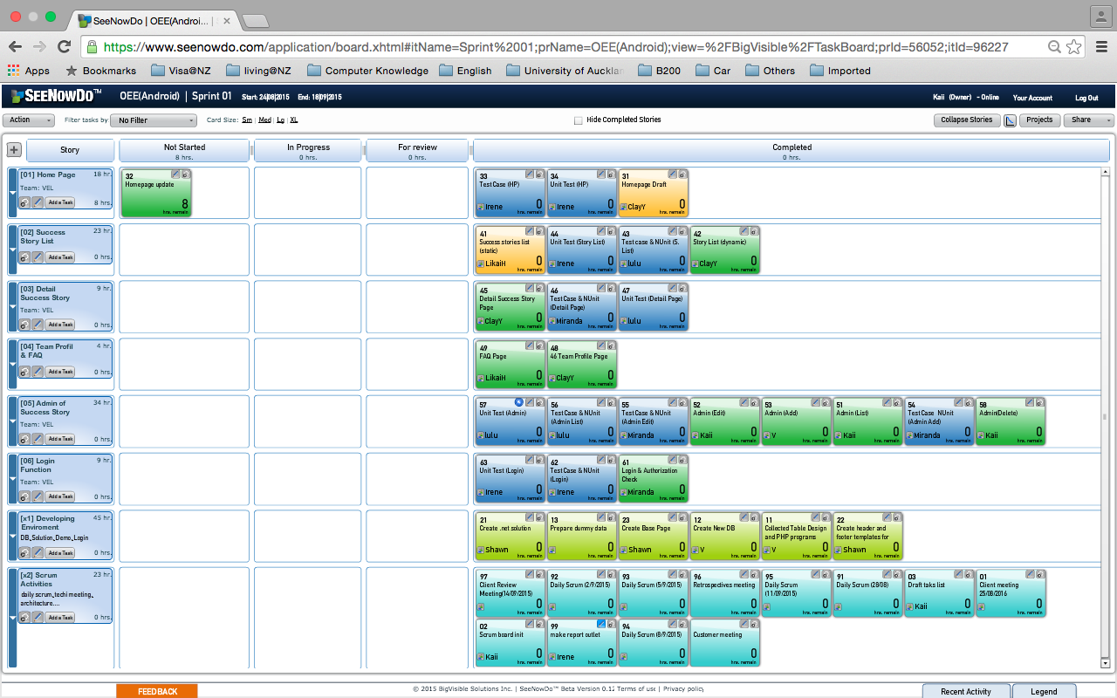

* Burn-down chart (By hours)

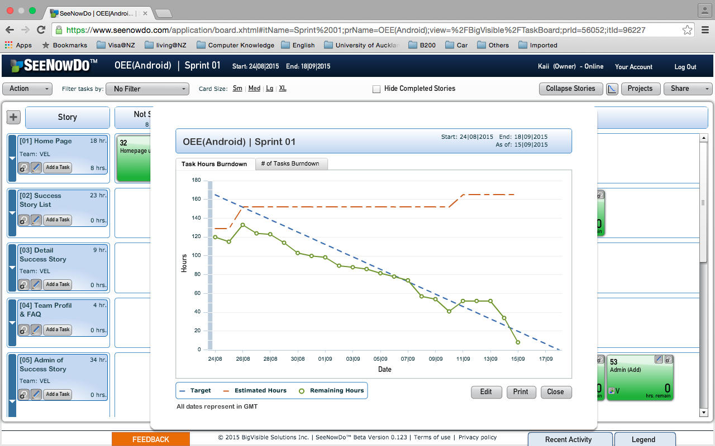

* Burn-down chart (By tasks)

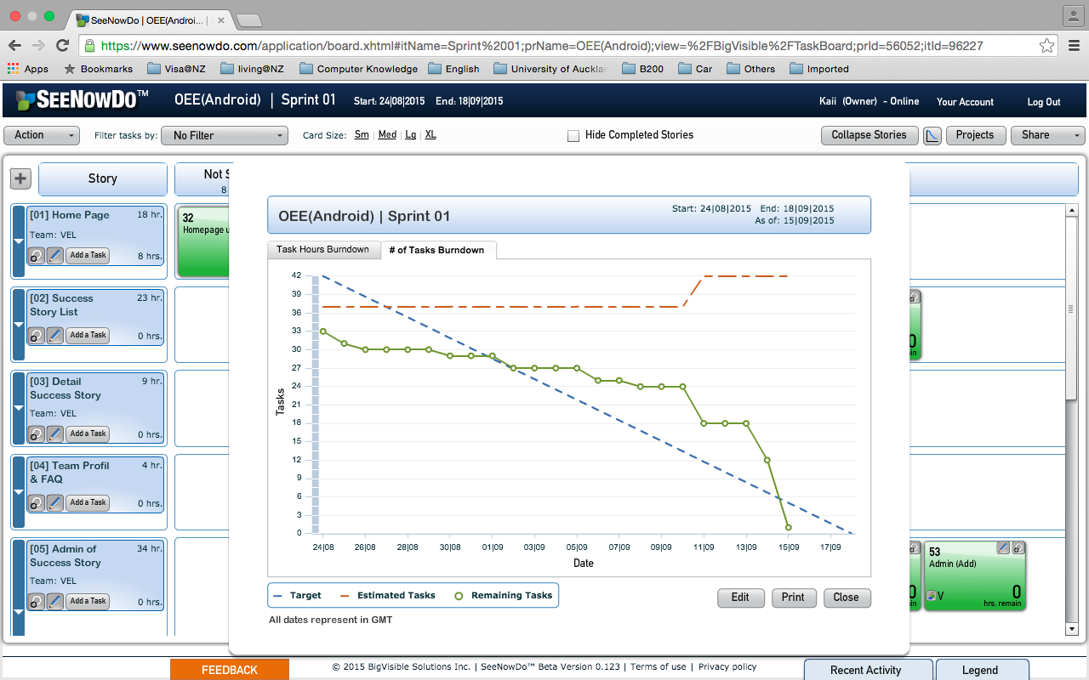

## Sprint Review

Our team had a Sprint Review meeting with the attendances of Scrum Master, team members and Product Owner–Yadwinder on September 14th. We’ve displayed our prototype to client. We’ve get positive feedbacks on most of our efforts for the project.

Product Owner–Yadwinder inspected the project and give us four suggestions in adapting the Prototype.

1. Team Profile pages need to be more colourful and interactive.

Add LinkedIn profile links of each members on Team Profile pages.

Design and provide Admin Pages for Team Profiles in next Sprint.

1. Shift “contact us” link form the footer to Navbar (Heater).
2. Adjust the pictures and ISTQB logos in Home Pages.
3. Add “share to social media (Twitter/Facebook) function” on Success Story List Pages and Success Story Detail Pages.

According to PO’s suggestions, we will adjust our project by the end of this Sprint on September 18th Fri.

## Retrospective

**Clay:** In this sprint I initiated the layout of the website using Bootstrap framework and carefully crafted the home page, success story list page and success story detail page. I have developed model class, controller and views for success story list and success story detail. By pair programming with Kaii, I have learned to develop controller in a very short time.

**Likai:** In this sprint, I focused on the mobile friendly static webpage. I designed a successful story list static webpage and work with Clay in FAQ page and Team Profile page. It is my first time to design a webpage and I already prepare some new knowledge (such as how to make a dynamic page) for the next sprint.

**Irene:** In this sprint, I put more efforts on writing test cases and unit tests by using NUnit. I have also gained some experience of mobile-friendly website development. By following agile development processes, I’ve been taught lots of useful knowledge and gained experiences from our group members.

**V:** By following the scrum, I played several different roles within one project, which is interesting one, which cannot be achieved in normal waterfall method. For example, some days as a Scrum master, some days DBA, some day’s software developer, some day’s Business Analyst which gives a feel of I had a full meals (Indian Food variety, with many items in the content).

**Miranda:** At first, I designed and built the database with V. Then I designed two login pages for choice and developed login pages for Admin with Shawn. In addition, I wrote test cases for admin pages and successstory pages with Lulu. I really learned a lot in this sprint and I hope I can do more work in the next sprint.

**Kaii:** Acted as scrum master in the first half of sprint one, assist the team in sprint meeting, system architecture, DB design, as well as the initialization of scrum board. Responded for the admin functions of success story and NUnite testing environment. Applied daily scum, estimation game, simple design, pair programming, small release, refactoring and coding standards to our project.

**Lulu:** For the first sprint, I built some models and designed several dynamic pages including about.chtml, contact.chtml and create.chtml. Besides, I completed test cases for AccountController and SuccessStoryController with Miranda. Finally, I wrote the prototype document with Irene and Miranda. Overall, I learned a lot in the process and tried to make contribution as much as possible.

**Shawn:** I organized solution in MVC architecture with demo codes. It’s widely used by the whole team. I also built and configured a remote Azure server and a remote MySQL server to support team demo. Layout template, included a footer and a header for front web page, is developed by myself. Miranda and I cooperated on developing login page for Admins.

# Sprint 02

## Delivered software increment

Since most of our tasks have been done during the first sprint and our customers are pretty satisfied with the outcomes, in the second sprint the team focused on refinements of the project.

To be specified, according to the feedbacks we got from customer representatives, first we modified the content layout on main page and fill the content with real data, which make the project practical. Then we added share buttons for each success stories on the story list page. We also create a new dynamic page about team profile for admins to manage. The automatic testing page, which is filled with introductive information about our customers’ main product, is implemented in this sprint as well. Furthermore, we integrated the “contact us” functionality on main page and linked it to the original API. Last but not least, as our customer required, our team also did some research about google searching strategies, providing them a report with suggestion for searching key words.

## Sprint backlog

|  |  |  |  |  |  |  |
| --- | --- | --- | --- | --- | --- | --- |
| Story  ID | Story  ID | Story  ID | Story  ID | Story  ID | Story  ID | Story  ID |
| 1 | Refine Home Page | 11 | Change carousel to success story & Height | ClayY | cyan988 | 5.0 |
|  | 12 | Website statistics | Irene | ygao742 | 3.0 |
|  | 13 | Test for carousel | Shawn | syu702 | 2.5 |
|  | 14 | Test for website statistics | LikaiH | lhe838 | 1.5 |
| 2 | Refine Success Story (List & Detail) | 21 | Share icons for social media | Shawn | syu702 | 6.0 |
|  |  | 22 | Refine success story list page | Lulu | jlu986 | 3.0 |
|  |  | 23 | Refine detail page | LikaiH | lhe838 | 3.0 |
|  |  | 24 | Test for social media shareing | Kaii | hxie519 | 3.0 |
|  |  | 25 | Test for success story list page | Kaii | hxie519 | 1.5 |
|  |  | 26 | Test for detail page | Irene | ygao742 | 1.5 |
| 3 | Team Profile Admin Function | 31 | Team profile dynamic page & Admin function | Miranda | yguo325 | 8.0 |
|  |  | 32 | Linkin Add-in | Shawn | syu702 | 1.0 |
|  |  | 33 | Test for team profile page | Kaii | hxie519 | 4.0 |
|  |  | 34 | Test for Linkin icon add-in | Kaii | hxie519 | 0.5 |
| 4 | Test automation page | 41 | Update description on HP and add detail page | ClayY | cyan988 | 4.0 |
|  |  | 42 | Test for Test automation (HP & detail) | Lulu | jlu986 | 2.0 |
| 5 | Contact Function | 51 | Add "contact us" function | V | vbor051 | 8.0 |
|  |  | 52 | Test for "contact us" function | LikaiH | lhe838 | 4.0 |
| 6 | Google Search Keyword | 61 | Google searching keywork | Irene | ygao742 | 4.0 |
| X1 | Scrum Activities | 01 | Sprint meeting | ALL members |  | 8.0 |
|  |  | 02 | Daily scrum (09/23) | ALL members |  | 4.0 |
|  |  | 04 | Daily scrum (10/02) | ALL members |  | 4.0 |
|  |  | 05 | Daily scrum (10/04) | ALL members |  | 4.0 |
|  |  | 06 | Daily scrum (10/05) | ALL members |  | 4.0 |
|  |  | 03 | Client Review (10/01) | ALL members |  | 3.0 |
|  |  | 07 | Client Review (02) | ALL members |  | 3.0 |
|  |  | 08 | Scrum Review meeting | ALL members |  | 6.0 |
|  |  |  |  |  |  |  |

## Development details

1. User story 1: Refine home page

URL: <http://getskills.azurewebsites.net/>

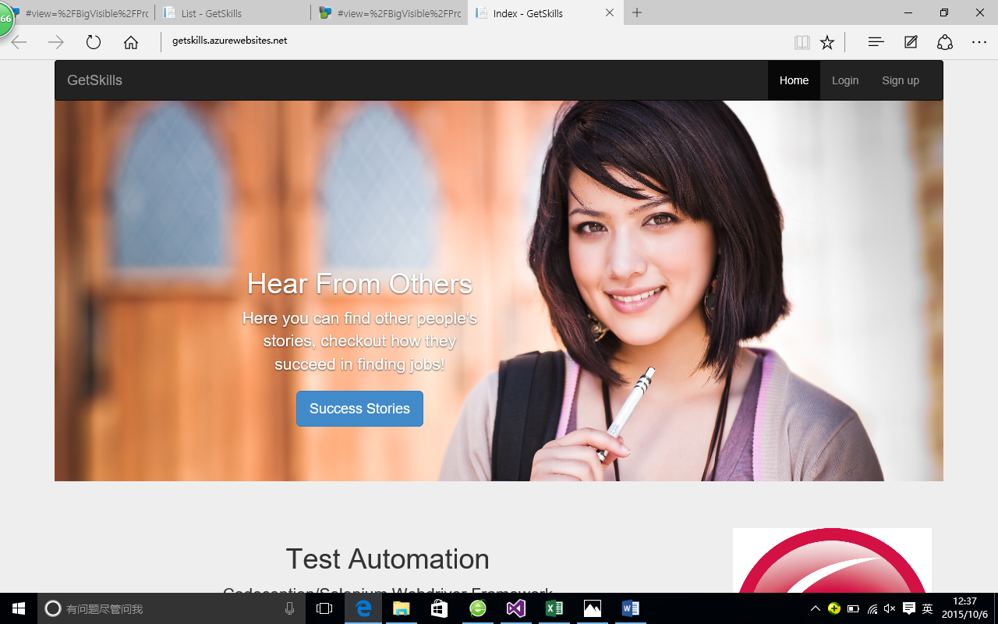

1. User story 2: Social share links

url: <http://getskills.azurewebsites.net/SuccessStory/List>

For each success story, there is a box of social sharing button to share the story on other social network website.

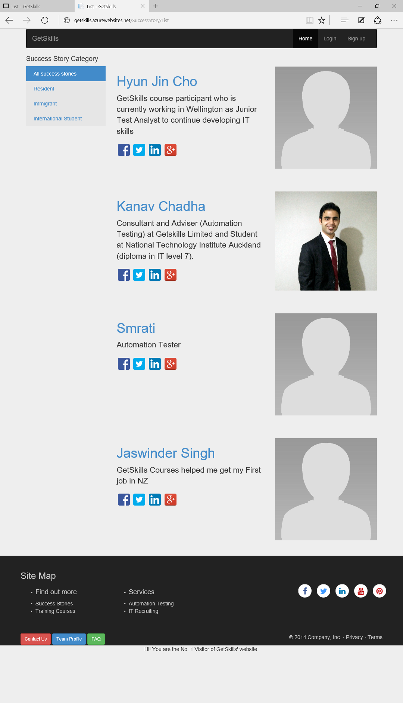

1. User story 3: Edit team profile and LinkedIn links

url: http://getskills.azurewebsites.net/TeamProfiles/List

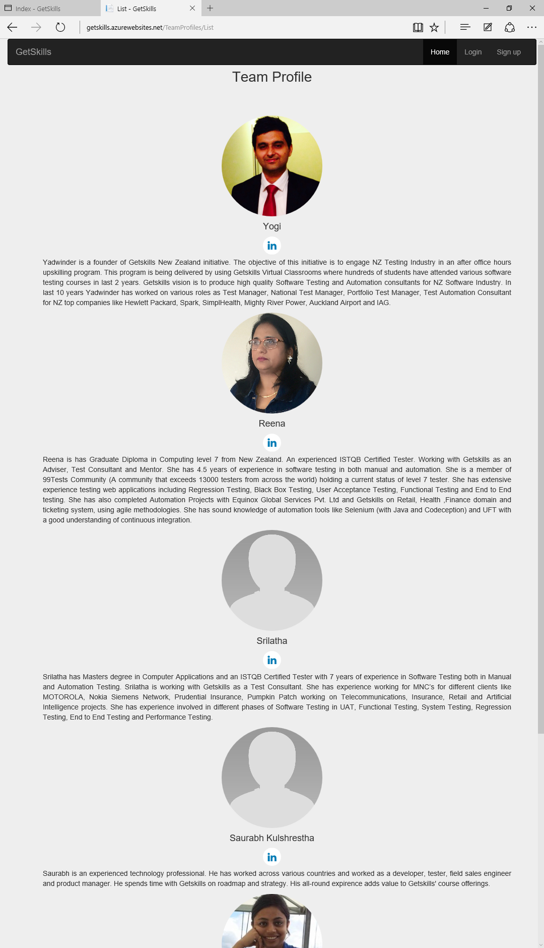

url: http://getskills.azurewebsites.net/TeamProfiles/Index

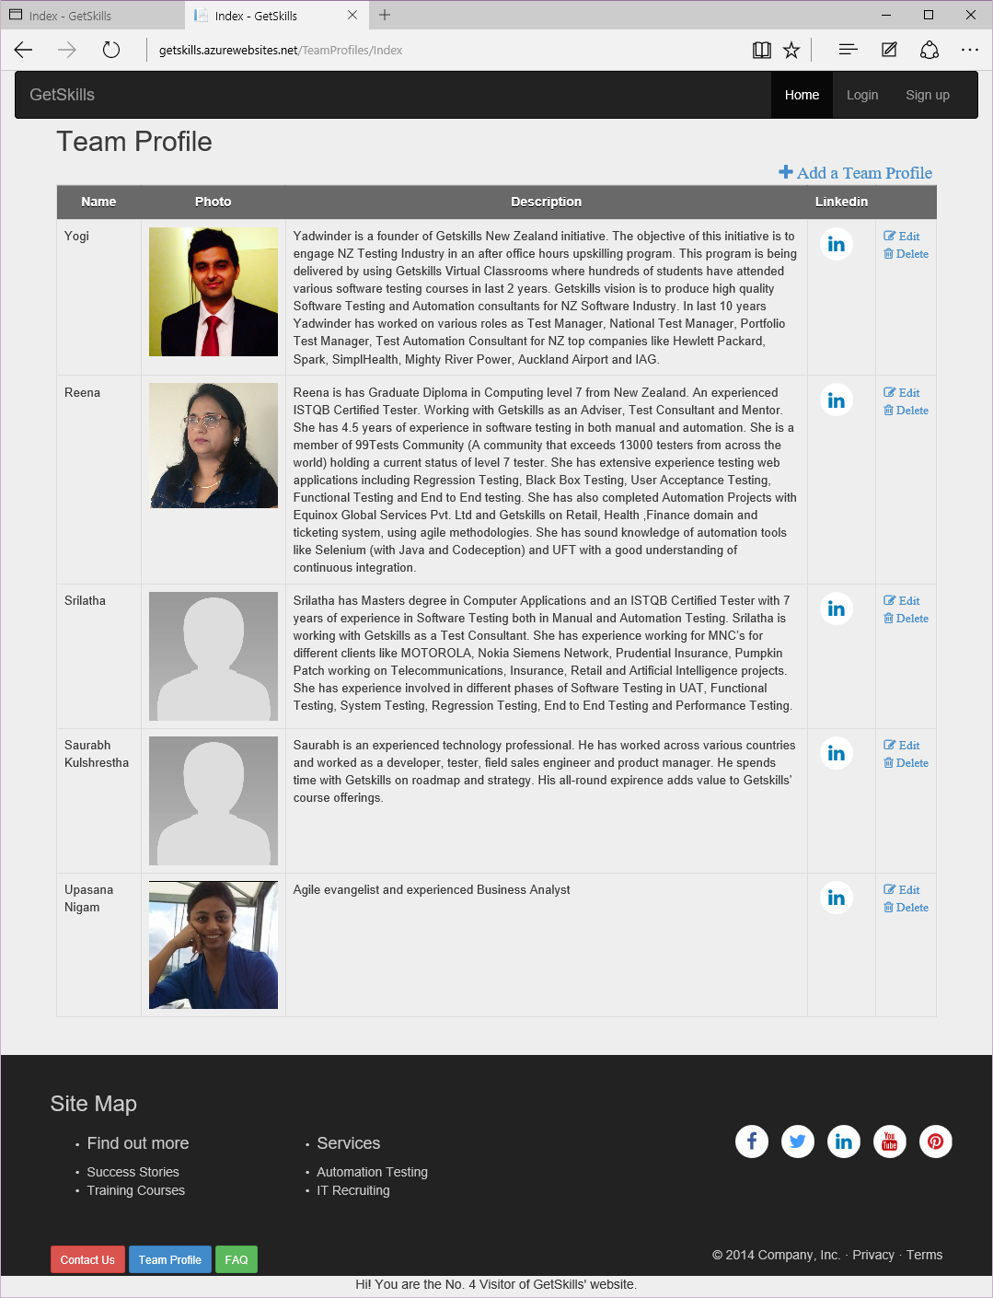

url: http://getskills.azurewebsites.net/TeamProfiles/Detial

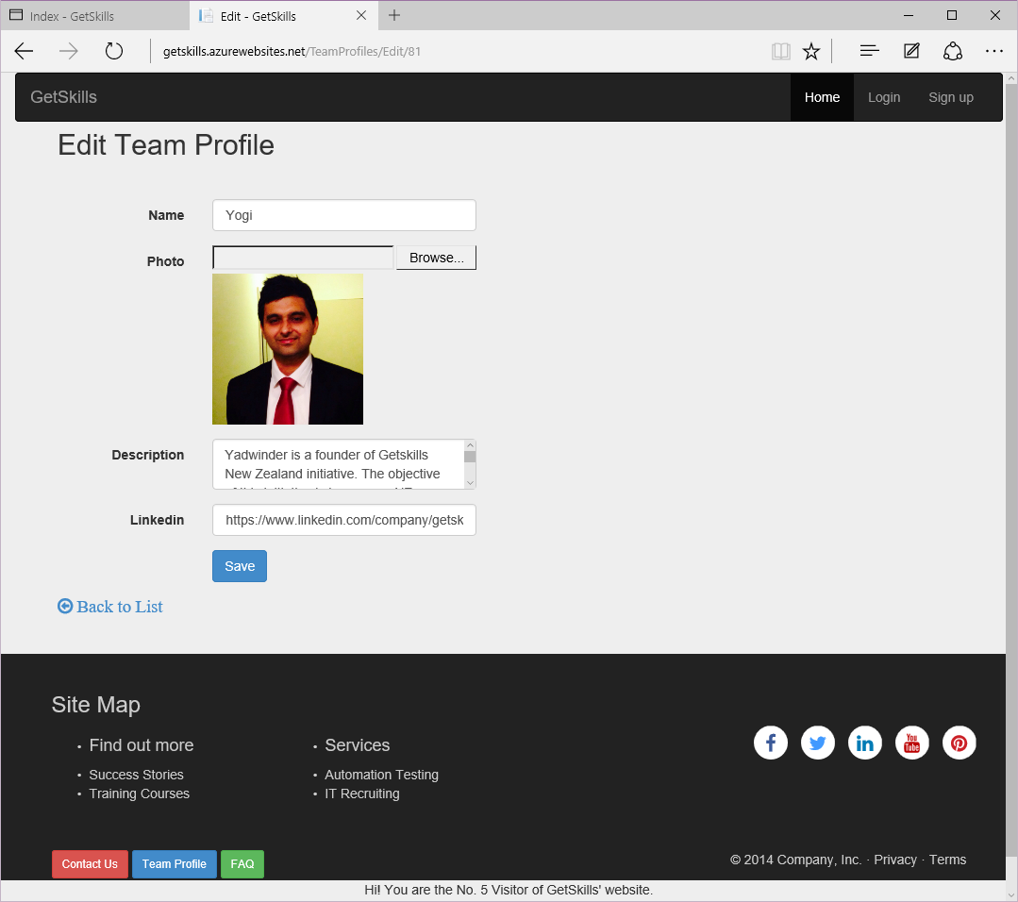

url: http://getskills.azurewebsites.net/TeamProfiles/Add

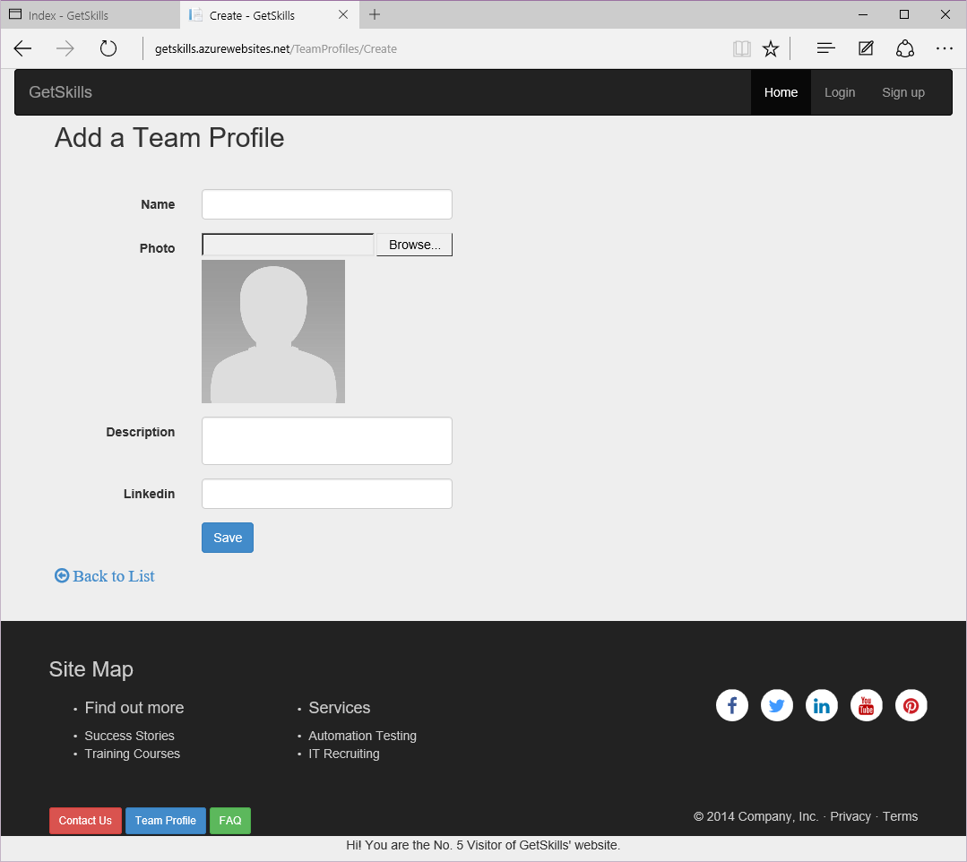

1. User story 4: Automation test page

url: http://getskills.azurewebsites.net/TestAutomation/Index

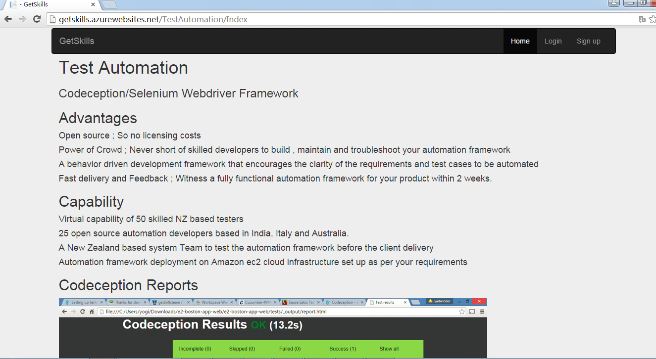

1. User story 5: Contact us

url: <http://getskills.azurewebsites.net/TestAutomation/Index>

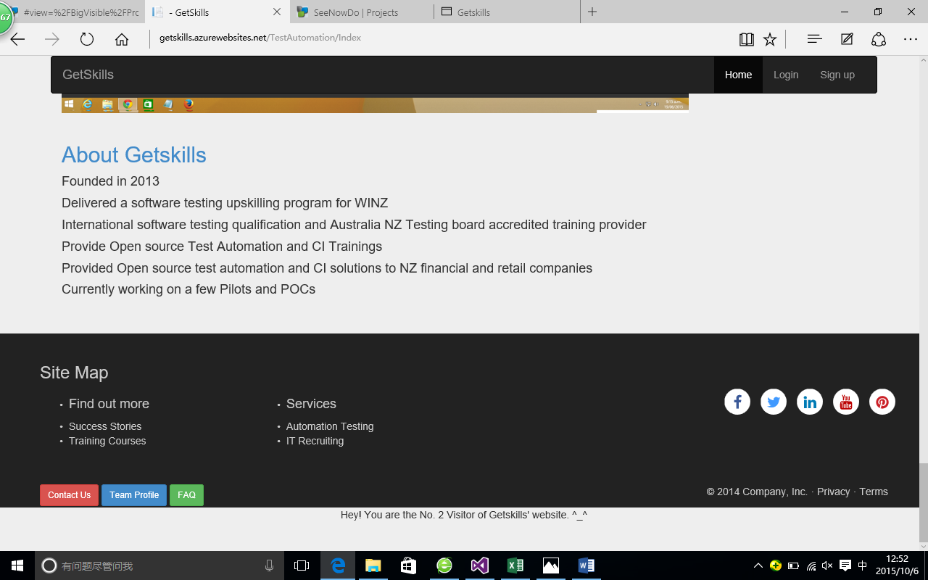

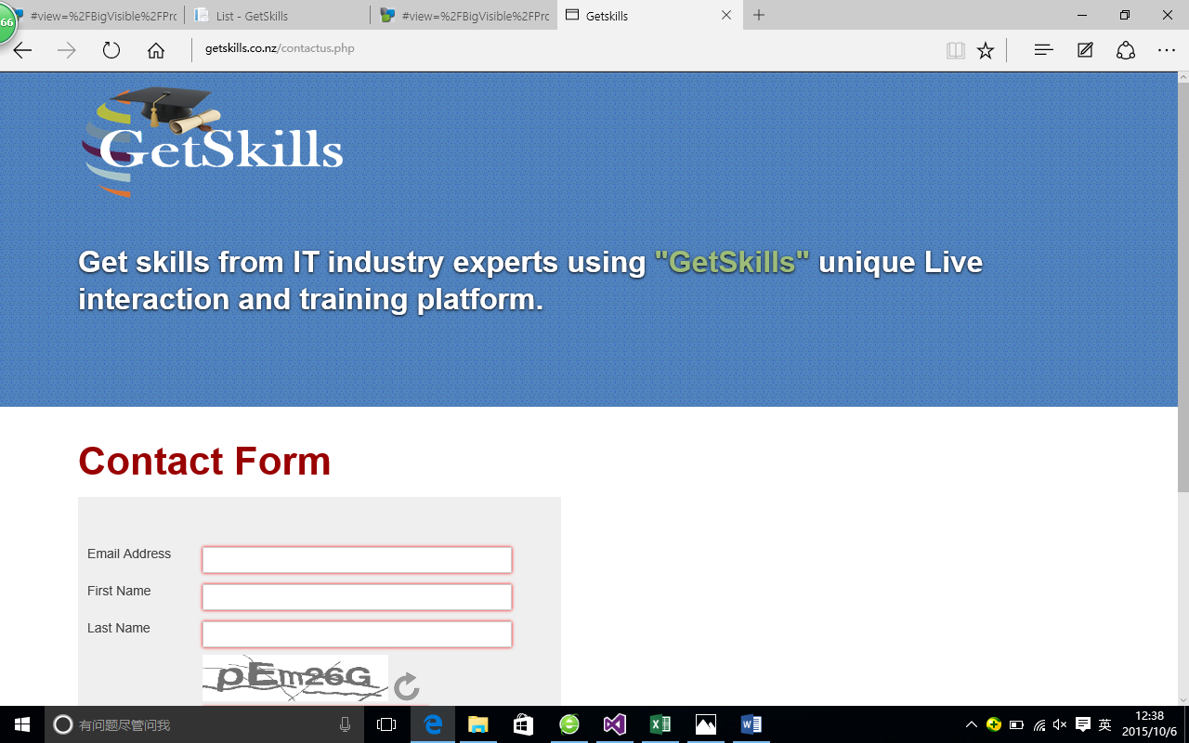

1. User story 6:Visitor counting

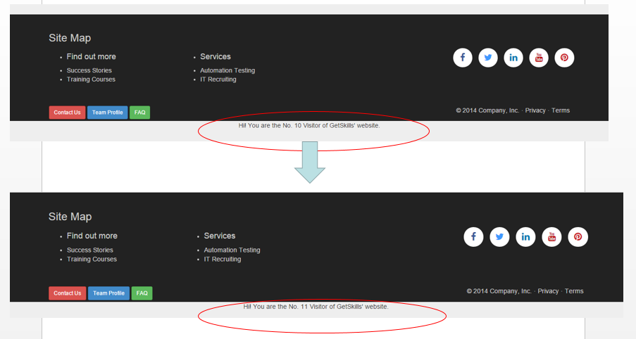

## Test results

1. **NUnit Test**

**Team profile page**

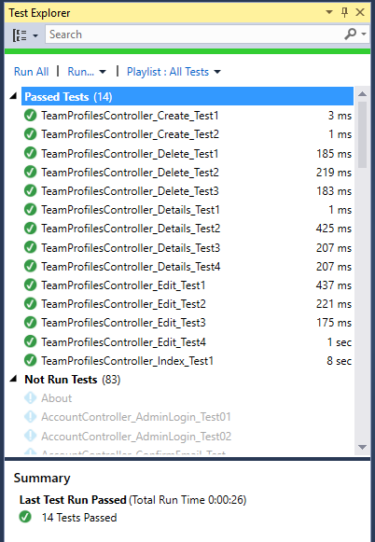

**Acceptance Tests**

User story 1: Refine the success story list page (client view)

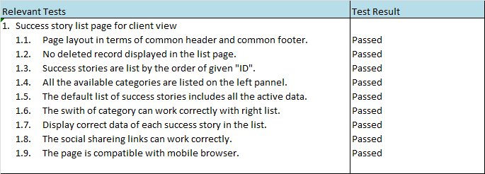

User story 2: Dynamic team profile page (client view).

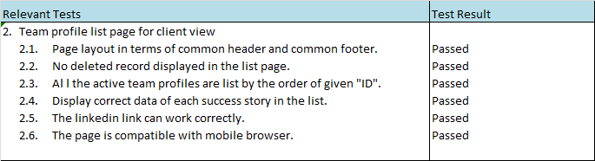

User story 3: Team profile admin functions

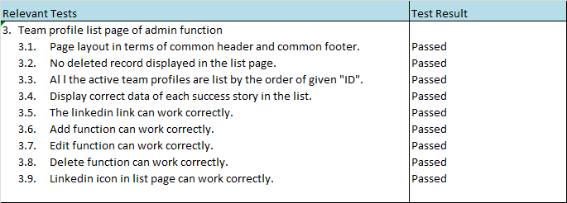

User story 4: Automatic testing page



User story 5: Website statistics

|  |  |  |  |  |  |  |  |  |  |  |  |  |  |  |  |  |  |  |  |  |  |  |  |  |  |  |  |  |  |  |  |  |  |  |  |
| --- | --- | --- | --- | --- | --- | --- | --- | --- | --- | --- | --- | --- | --- | --- | --- | --- | --- | --- | --- | --- | --- | --- | --- | --- | --- | --- | --- | --- | --- | --- | --- | --- | --- | --- | --- |
|  | | |  |  |  |  |  |  |  |  |  |  |  |  |  |  |  |  |  |  |  |  |  |  |  |  |  |  |  |  |  |  |  |  |  |
| Relevant Tests | | | |  |  |  |  |  |  |  |  |  |  |  |  |  |  |  |  |  |  |  |  |  |  | Test Result | | | |  |  |  |  |  |  |
| 1. | Website satistics | | | |  |  |  |  |  |  |  |  |  |  |  |  |  |  |  |  |  |  |  |  |  |  |  |  |  |  |  |  |  |  |  |
|  | 1.1. | | Page layout in terms of common header and common footer. | | | | | | | | | | | | | | | | | |  |  |  |  |  | Passed | | |  |  |  |  |  |  |  |
|  | 1.2. | | The layout should be in the end of the webpage. | | | | | | | | | | | | | |  |  |  |  |  |  |  |  |  | Passed | | |  |  |  |  |  |  |  |
|  | 1.3. | | After one more people visit the webipage the counter will add one. | | | | | | | | | | | | | | | | | | | |  |  |  | Passed | | |  |  |  |  |  |  |  |
|  |  |  |  |  |  |  |  |  |  |  |  |  |  |  |  |  |  |  |  |  |  |  |  |  |  |  |  |  |  |  |  |  |  |  |  |
|  |  |  |  |  |  |  |  |  |  |  |  |  |  |  |  |  |  |  |  |  |  |  |  |  |  |  |  |  |  |  |  |  |  |  |  |

## Sprint Management

## Sprint review

Our team had a Sprint Review meeting with the attendances of Scrum Master, team members and Product Owner–Yadwinder on October 2nd. We’ve demonstrated our final version product to client. The customers are very satisfied and showed interests for further coorperation.

## Individual retrospective

**Kaii:** Cooperate with other team members to apply agile practices in our project; acted as a scrum mater in the first half of sprint one; contributed my main efforts on estimation, system architecture, DB design, layout design, programming, testing and project management; Meanwhile, I still need more effort on the coordination among team members and helping others with technical issues.

**Miranda**: For the second sprint, I focused on the team profile pages, including the dynamic page for website’s users and admin pages for administrators. Now the administrators can scan, create, edit and delete team profiles. And the users can scan the team profiles for the website. Overall, I created four website pages and refined one page in this sprint.

**Lulu**: In the first week of the second sprint, as the scrum master, I organized the sprint planning meeting for our team. My major task is to refine the success story list page. Now the users can scan the success stories according to their categories. In addition, I completed the unit test for test automation.

**Shawn**: In this sprint, I integrated APIs of Facebook, Twitter, Google and LinkedIn to our project, successfully implementing share buttons for social networking. Meanwhile, I also added LinkedIn links for each member in the team profile page.

**Likai**: In this sprint. I focus on the test. I learned how to write a test case and how to use Nunit to test code. I have two test at beginning but one of them cannot be implement, because the customer delete his requirement, so I supplement some test case from last sprint to make them better.

**Clay:** In this sprint, I created test automation page, finished design and development tasks. Meanwhile, I managed to polish home page, changed its layout, updating action buttons. I got the feedback from tester, which is contributed to the project. It's very helpful to have team working around, so that we can achieve a better outcome.

**Irene:** In the second sprint, my task is to develop website counter which can record visitor statistics. I've tried many ways in implementing the task and finally achieved at an acceptable solution. During the second sprint, I've got more familiar with the agile development processes and adapted with the pace of Scrum.

**V:** Push (from testing) and pull (development) from our VEL team helped me to complete the work successfully. EGO is one thing that went away from me in the project, which is key for Successful as a Team. ‘Appreciations’ is another good thing that I made to our team members.

# Group Evaluation

In general, our group did a good job for the two sprints and achieved a satisfied result. We defined a reasonable sprint backlog and followed SCRUM process strictly. Everyone got one task at first and after finished it he/she could get another task. We held stand-up meetings regularly so that we could know each other’s progress and obstacles. If anyone had a problem, others would help him/her. Some of us did not have programming experience before, so their progress might be slow. But everyone tried to finish the tasks as soon as possible and make the project perfect. Besides, every scrum master communicated with our customer as much as possible to ensure that the project could meet the demands.